e

Project Design Phase-II Technology Stack (Architecture & Stack)

Date | 15 October 2022
Team ID | PNT2022TMID47645
Project Name | Project – Smart Farmer-IoT enabled smart  farming application.
Maximum Marks | 4 Marks

Technical Architecture:
The Deliverable shall include the architectural diagram as below and the information as per the table1 & table 2

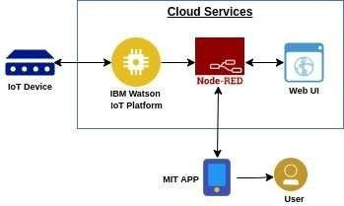

Table-1 : Components & Technologies:
S.No | Component | Description | Technology
1. | User Interface | How user interacts with application e.g. Web UI, Mobile App, Chatbot etc. | MIT app
2. | Application Logic-1 | Logic for a process in the application | Node red/IBM Watson/MIT app
3. | Application Logic-2 | Logic for a process in the application | Node red/IBM Watson/MIT app
4. | Application Logic-3 | Logic for a process in the application | Node red/IBM Watson/MIT app
5. | Database | Data Type, Configurations etc. | MySQL, NoSQL, etc.
6. | Cloud Database | Database Service on Cloud | IBM cloud.
7. | Temperature sensor | Monitors the temperature of the crop
8. | Humidity sensor | Monitors the humidity
9. | Soil moisture sensor (Tensiometers) | Monitors the soil temperature
10. | Weather sensor | Monitors the weather | .

11. | Solar panel |  | .
12. | RTC module | Date and time configuration
13. | Relay | To get the soil moisture data

Table-2: Application Characteristics:
S.No | Characteristics | Description | Technology
1. | Open-Source Frameworks | MIT app,Node-Red | Software
2. | Scalable Architecture | Drone technology, pesticide monitoring ,Mineral identification in soil | Hardware

